Defect Report
Defect ID: BAC-01
Summary: Delete customer details failing
Description:
https method: Delete
Endpoint: customers/{customerID}
Precondition: Customer and Account should be exists
Step to Reproduce:
- When user executed delete customer request
- Customer should be deleted from system
- Validate the delete customer details using get customer request
Expected Result : Expected response code should be 404
Actual Result: Getting response code as 200

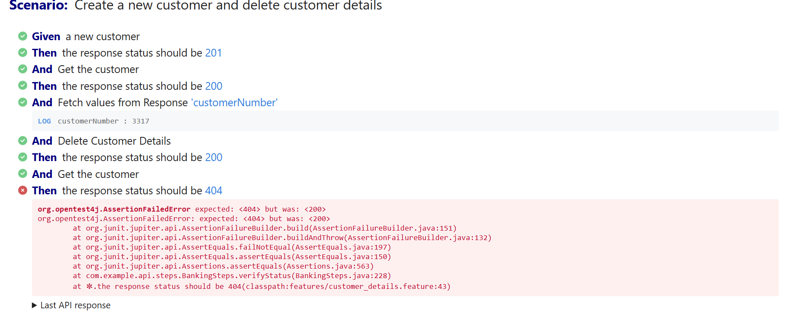

Defect ID : BAC-02
Summary: Get Account details request giving 302 response code
Description:
https method: Get
Endpoint: accounts/{accountNumber}
Precondition: Customer and Account should be exists
Step to Reproduce:
- When user executed get account request
- Account details should be retrieved

Expected Result: Expected response code should be 200
Actual Result: Getting response code as 302

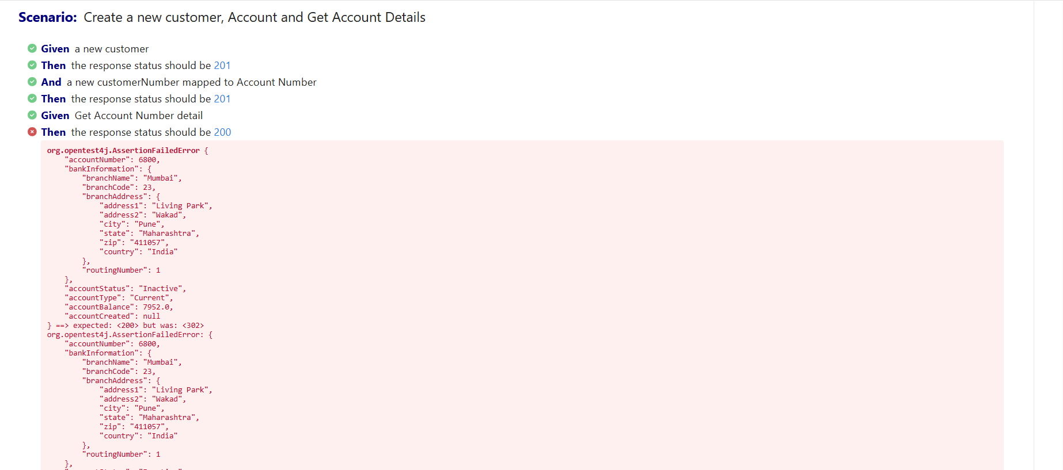

Defect ID : BAC-03
Summary: Invalid amount transfer
Description:
https method: put
Endpoint: /accounts/transfer/{customerID}
Precondition:
1.From Customer and Account should be exists
2.To customer Account details
Step to Reproduce:
- When user executed put transfer request
- For invalid value transfer should be failed(Negative Amount)

Expected Result: Expected response code should be 400
Actual Result: Getting response code as 200

